Name:________________________________________ Date:__________

Humanities

To Kill a Mockingbird: Research Activity

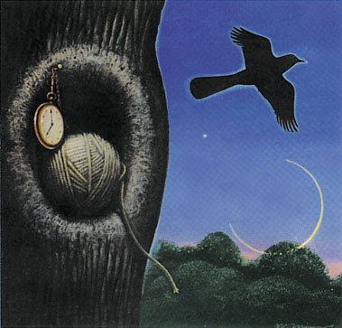

To culminate our unit on To Kill a Mockingbird and to give you the opportunity to apply the wonderful research strategies you learned in library orientation, you will be conducting in-depth research on a topic that we have discussed in relationship to To Kill a Mockingbird. This research activity will help you answer some elusive questions: What was life really like for Jem and Scout in Maycomb, Alabama during the Great Depression? What historical events may have influenced Harper Lee when she was writing this book?

How will the research process be conducted for this activity?

- You and a partner will be assigned a topic and an MI that you will need to prove through your research.

- You will be given a research notes worksheet that you will complete as you conduct your research. You will be working on this both in the library and at home. Each research notes sheet contains specific questions pertaining to your topic that you have to answer by consulting a variety of sources: books, database articles, credible websites, etc. Each person has to develop and submit his or her own individual notes. In a way, this is like a scavenger hunt.

- You will create an outline of a research paper that supports your assigned MI and presents the findings of your research. Each person has to develop and submit his or her own typed outline.

- You will use the outline to compose a two-page research paper that supports your MI and presents the findings of your research in a clear, cohesive, and well-organized manner. A Works Cited page will accompany your research paper. Each person has to develop and submit his or her own typed research paper.

You will be provided with plenty of structure and support for this project along the way! The breakdown of the assignment is as follows:

Research Notes Sheet: 50 points
Research Paper Outline: 50 points

Research Paper Final Draft: 100 points

Topics
Topic #1: Life for African Americans in the South Following the Civil War
Topic #2: America and the World in the 1930s: The Economy During the Time Period of To Kill a Mockingbird
Topic #3: The Rise of African American Culture after the Civil War
Topic #4: Beyond the Book: The Culture of To Kill a Mockingbird

